**Code**

#include<iostream>

#include<cmath>

using namespace std;

int a[8]={0,0,0,0,1,1,1,1};

int b[8]={0,0,1,1,0,0,1,1};

int c[8]={0,1,0,1,0,1,0,1};

int x[4]={0,0,1,1};

int y[4]={0,1,0,1};

int v;

void AND()

{

if(v==3)

{

cout<<"\nA | B | C | AND"<<endl;

for(int i=0;i<pow(2,v);i++)

cout<<a[i]<<" | "<<b[i]<<" | "<<c[i]<<" | "<<((a[i]&b[i])&c[i])<<endl;

}

else if(v==2)

{

cout<<"\nA | B | AND"<<endl;

for(int i=0;i<pow(2,v);i++)

cout<<x[i]<<" | "<<y[i]<<" | "<<(x[i]&y[i])<<endl;

}

}

void OR()

{

if(v==3)

{

cout<<"\nA | B | C | OR"<<endl;

for(int i=0;i<pow(2,v);i++)

{

cout<<a[i]<<" | "<<b[i]<<" | "<<c[i]<<" | "<<((a[i]|b[i])|c[i])<<endl;

}

}

else if(v==2)

{

cout<<"\nA | B | OR"<<endl;

for(int i=0;i<pow(2,v);i++)

{

cout<<x[i]<<" | "<<y[i]<<" | "<<(x[i]|y[i])<<endl;

}

}

}

void NOT()

{

cout<<"\nA | NOT of A"<<endl;

for(int i=0;i<2;i++)

{

cout<<i<<" | "<<!i<<endl;

}

}

void XOR()

{

if(v==3)

{

cout<<"\nA | B | C | XOR"<<endl;

for(int i=0;i<pow(2,v);i++)

{

cout<<a[i]<<" | "<<b[i]<<" | "<<c[i]<<" | "<<((a[i]^b[i])^c[i])<<endl;

}

}

else if(v==2)

{

cout<<"\nA | B | XOR"<<endl;

for(int i=0;i<pow(2,v);i++)

{

cout<<x[i]<<" | "<<y[i]<<" | "<<(x[i]^y[i])<<endl;

}

}

}

void CO()

{

if(v==3)

{

cout<<"\nA | B | C | (A -> B) -> C"<<endl;

for(int i=0;i<pow(2,v);i++)

{

cout<<a[i]<<" | "<<b[i]<<" | "<<c[i]<<" | "<<(!((!a[i])|(b[i]))|(c[i]))<<endl;

}

}

else if(v==2)

{

cout<<"\nA | B | A -> B"<<endl;

for(int i=0;i<pow(2,v);i++)

cout<<x[i]<<" | "<<y[i]<<" | "<<((!x[i])|(y[i]))<<endl;

}

}

void BCO()

{

if(v==3)

{

cout<<"\nA | B | C | (A <-> B) <-> C"<<endl;

for(int i=0;i<pow(2,v);i++)

{

cout<<a[i]<<" | "<<b[i]<<" | "<<c[i]<<" | "<<((!((!a[i])|(b[i]))|(c[i]))&(!(c[i])|((!b[i])|(a[i]))))<<endl;

}

}

else if(v==2)

{

cout<<"\nA | B | A <-> B"<<endl;

for(int i=0;i<pow(2,v);i++)

cout<<x[i]<<" | "<<y[i]<<" | "<<(((!x[i])|(y[i]))&((!y[i])|(x[i])))<<endl;

}

}

void menu()

{

int op;

cout<<"1. AND"<<endl;

cout<<"2. OR"<<endl;

cout<<"3. NOT"<<endl;

cout<<"4. XOR"<<endl;

cout<<"5. Conditional Operator"<<endl;

cout<<"6. Bi-Conditional Operator"<<endl;

cout<<"Enter your Option (1 ~ 5): ";

cin>>op;

cout<<"\n*** TRUTH TABLE ***"<<endl;

switch(op)

{

case 1:

AND();

break;

case 2:

OR();

break;

case 3:

NOT();

break;

case 4:

XOR();

break;

case 5:

CO();

break;

case 6:

BCO();

break;

default:

cout<<"Please Choose between 1 to 6"<<endl;

break;

}

}

int main()

{

cout<<"How many Variables (2/3): ";

cin>>v;

menu();

return 0;

}

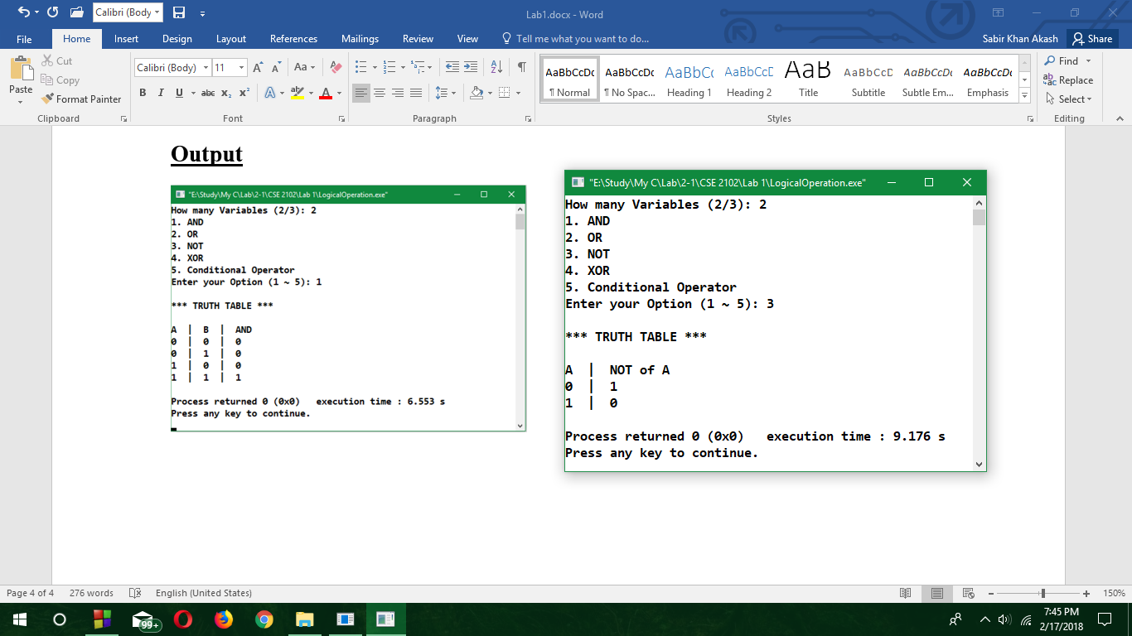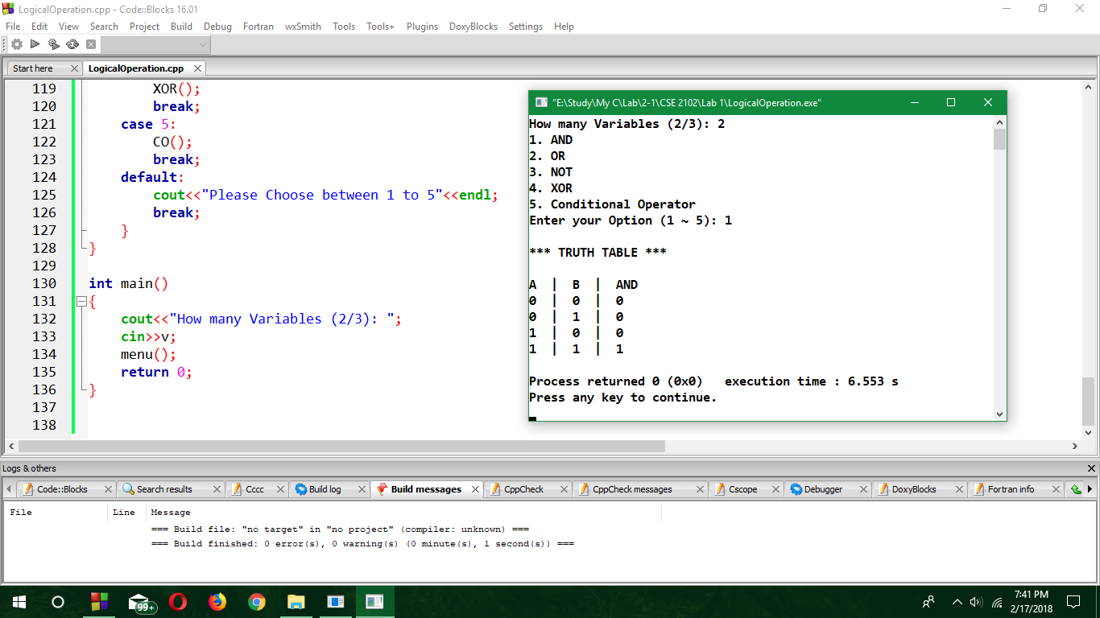**Output**

